Work Log: Computer Science 2.4 Assessment
Date: | What I did today: | Evidence:
11/06/2026 | Today I was looking at colour palettes for my mobile smart attendance website. I found three colour palettes that both had contrast with dark colours mixed with light colour, so it is easy to see text. I am still deciding between the three as I need to see which one would best suit my mobile app. | 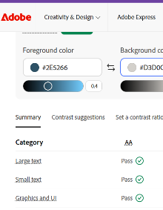  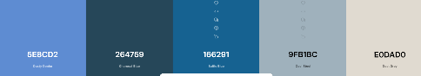  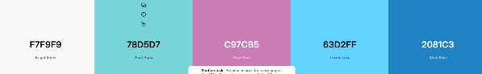  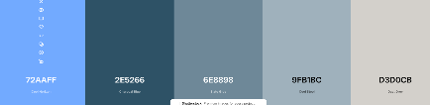
22/06/2026 | Today I started to work on my code. I first was working on the main smart attendance page for iPhone and laptops. The first component I was working on was adding a button to turn on the camera. After I did this I made it so that the camera picture displays on the page. After that I added in my colour palette so it has a nice aesthetic, and It was looking pretty good. My next step is to make the camera pick up on barcodes so I can link it so a name so they can mark themselves into a club. | 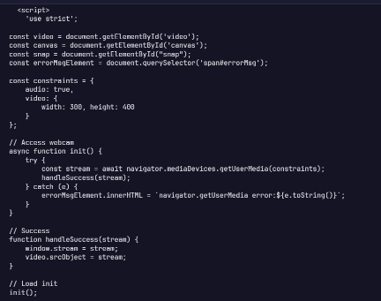  w

Complex errors:

